**TUGAS 7.1**

**CODING**

package javaapplication3;

import java.util.Scanner;

public class JavaApplication3 {

// Penjumlahan

static int Penjumlahan(int n){

if(n==1 || n==0){

return 1;

}

else{

return Penjumlahan(n-1)+n;

}

}

// Perkalian

static int Perkalian(int n){

if(n==1 || n==0){

return 1;

}

else{

return Perkalian(n-1)*n;

}

}

public static void main(String[] args) {

Scanner input = new Scanner(System.in);

int angka,penjumlahan,perkalian;

System.out.print("Masukkan Angka : ");

angka = input.nextInt();

for(int i=angka-1; i>=0; i--){

System.out.print(i+1);

if(i<=angka && i>0){

System.out.print("+");

}

if(i<=0){

penjumlahan = Penjumlahan(angka);

System.out.println("="+penjumlahan);

}

}

for(int i=angka-1; i>=0; i--){

System.out.print(i+1);

if(i<=angka && i>0){

System.out.print("x");

}

if(i<=0){

perkalian = Perkalian(angka);

System.out.println("="+perkalian);

}

}

}

}

**OUTPUT**

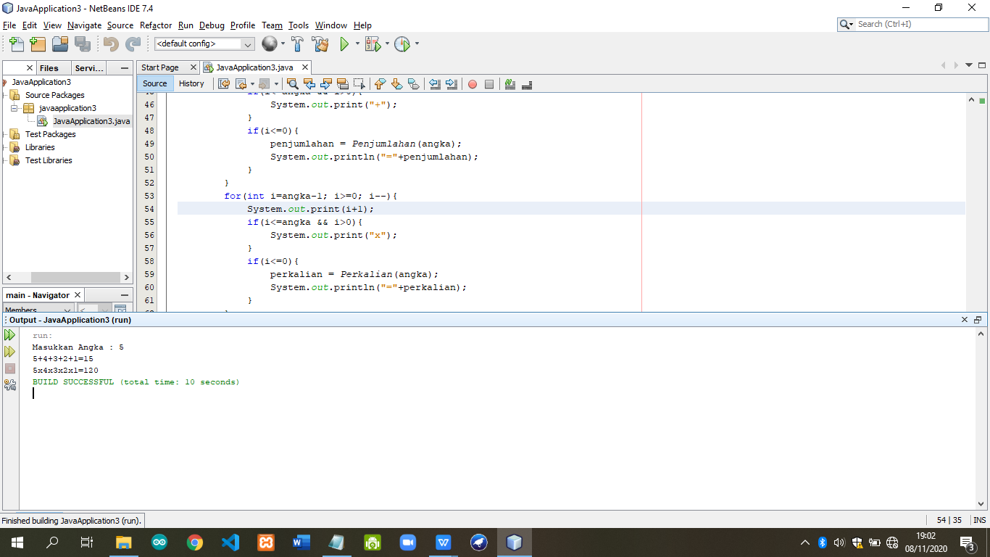

**TUGAS 7.2**

**CODING**

package java_7_2;

import java.util.Scanner;

public class Java_7_2 {

static int Fibonanci(int n){

if(n==1 || n==0){

return 1;

}

else{

return Fibonanci(n-1)+Fibonanci(n-2);

}

}

public static void main(String[] args) {

Scanner input = new Scanner(System.in);

String kondisi="";

int n,hasil;

do{

System.out.print("Masukkann nilai n : ");

n = input.nextInt();

System.out.print("Fibonanci dari = "+n+" : ");

for(int i=0; i<n; i++){

hasil = Fibonanci(i);

System.out.print(hasil+" ");

}

System.out.println();

System.out.println();

System.out.print("Ulangi lagi(y/n) : ");

kondisi = input.next();

}while(kondisi.equalsIgnoreCase("y"));

}

}

**OUTPUT**

